SULIT
UNIVERSITI TEKNOLOGI MALAYSIA
Faculty of Computing
UNIVERSITI TEKNOLOGI MALAYSIA FINAL EXAMINATION SEMESTER 1 , 2017 / 2018
SUBJECT CODE SUBJECT NAME SECTION
TIME
DATE/DAY
VENUES
INSTRUCTIONS:
SCSR 2043 /SCSS 4213 OPERATING SYSTEMS ALL
9. 00 AM - 11. 30 AM 08 / 01/2018( MONDAY) BK 2 ( N 28 )
Answer ALL questions in section A and section B in the answer booklet given.
Name
I/C No.
Year / Course
Section
Lecturer Name
This questions paper consists of ELEVEN ( 1 1 ) printed pages excluding this page.
SECTION A
MULTIPLE CHOICE QUESTIONS (20 MARKS)
(INSTRUCTION: Write all your answers in the answer booklet provided)
1. Which of the following statements is FALSE regarding deadlock states?
A. A deadlock state is an unsafe state.
B. An unsafe state is a deadlock state.
C. An unsafe state is not a deadlock state.
D. Not all unsafe states is a deadlock. However, an unsafe state may cause a deadlock.
2. Which of the following statements is TRUE regarding deadlocks?
A. Several processes may deadlock for an infinite number of resources. B. Deadlock can be avoided by allowing all four conditions to hold.
C. Deadlock can lead to starvation.
D. Deadlock can happened to independent processes.
3. _________ is a contiguous memory partitioning scheme, while_____________is a non contiguous memory partitioning scheme.
A. Segmentation, dynamic partition
B. Dynamic partition, relocatable dynamic partition
C. Paging, relocatable dynamic partition
D. Relocatable dynamic partition, segmentation
4. The following statements is about Compaction, EXCEPT:
A. Merge or combine the adjacent holes.
B. Reduce internal fragmentation.
C. All process can be moved to the one end of memory.
D. Possible only if relocation is dynamic.
5. Which of the following statements about Paging is FALSE?
A. In Paging, program pages will be loaded into frames.
B. Internal fragmentation may still occurred in the last page.
C. If the Page Size is too large, excessive internal fragmentation may happened. D. A Page Table is needed to do mapping of physical address to logical address. i
6. Which of the following statements regarding Segmented Memory Allocation is FALSE? A. External fragmentation may occur on the last segment.
B. Programs are allocated dynamically.
C. Internal fragmentation is eliminated finallly.
D. Segments are of different sizes.
7. The following phrases or statements are TRUE for paging EXCEPT: A. Main memory is allocated dynamically.
B. Difficulty in managing page faults.
C. Needs segment table.
D. Equal page size.
8. In virtual memory demand-paging table, there is a column called valid-invalid bit. What is the purpose of this valid-invalid bit?
A. To indicate whether the currently being accessed page need to be updated. B. To indicate whether the swapper is in error state or not.
C. To indicate whether the currently being accessed page is currently in the memory or not.
D. To indicate the process is invalid to be executed due to limited memory size that available for the process execution.
9. With virtual memory, size of logical memory of a jo b __________ . A. must be less than the size of the physical memory B. may be greater than the size of the physical memory C. must be equal to the size of the secondary storage D. may be greater than the size of the secondary storage
10. Which of the following is NOT a reason to implement non-contiguous memory allocation scheme?
A. Increase the complexity of the operating systems memory management. B. Elimination of compaction scheme.
C. Avoidance of external fragmentation between page frames.
D. Efficient usage of main memory.
2
11. Files are stored on the following devices or mediums EXCEPT: A. primary storage and databases
B. secondary and tertiary storages
C. magnetic and optical storages
D. disks and tapes
12. There could be many external fragmentation and difficulty in file expansion occurred in the_______________ allocation method.
A. Contiguous
B. Non-contiguous
C. Multi-level Indexed
D. Linked
13. The following statements most probably try to describe______________ . S Inward sweep stops at last high-numbered track request.
■S No last track access unless required.
A. FCFS
B. C-Look
C. SSTF
D. C-Scan
14. Two common and main issues of using RAID for servers are
A. performance and implementation issues
B. performance and redundancy issues
C. performance and reliability issues
D. performance and security issues
15. Disk performance or disk access time is normally based on the following EXCEPT: A. seek time
B. waiting
C. transfer
D. latency
3
16. In Least Recently Used (LRU) page replacement algorithm, when a page must be replaced,______________ .
A. last page is chosen
B. newest page is chosen
C. random page is chosen
D. oldest page accessed is chosen
17. Which of the following specifications describe RAID 5 clearly?
A. It requires one disk for redundancy.
B. Upon failure of a single drive, subsequent reads can be calculated from the strip parity such that no data is lost.
C. It consists of block-level striping with distributed parity.
D. It has designated parity disk.
18. In a tree-structured directory, the series of directory names that culminates in a file name is referred to as the .
A. Current Working Directory
B. File-system
C. Pathname
D. Symbolic name
19. The following allocation methods is best suited for files EXCEPT:
A. Contiguous—if file is usually accessed sequentially, and if file is relatively big. B. Linked—if file is large and usually accessed sequentially.
C. Indexed—if file is large and usually accessed randomly.
D. Linked—if file is small and usually accessed sequentially.
20. These techniques can be used in managing free disk space EXCEPT:
A. Linked List
B. Swap space
C. Bitmaps
D. File Allocation Table
4
SECTION B
STRUCTURED QUESTIONS (80 MARKS)
(INSTRUCTION: Write all your answers in the answer booklet provided) QUESTION 1 ri5 MARKS!
a) Figure 1 shows 3 processes {P1,P2,P3} with 3 types of resources {R1,R2,R3}. Does the RAG below exhibit a deadlock? Justify your answer. [5 marks]
b) Given the following resource allocation and availability in Table 1.
Table 1
Allocation Maximum Available
A B C A B C
PI 2 2 1 6 2 6
P2 0 1 1 8 4 8
P3 2 1 0 7 4 6
P4 1 0 1 2 0 3
P5 1 0 1 8 3 7
5
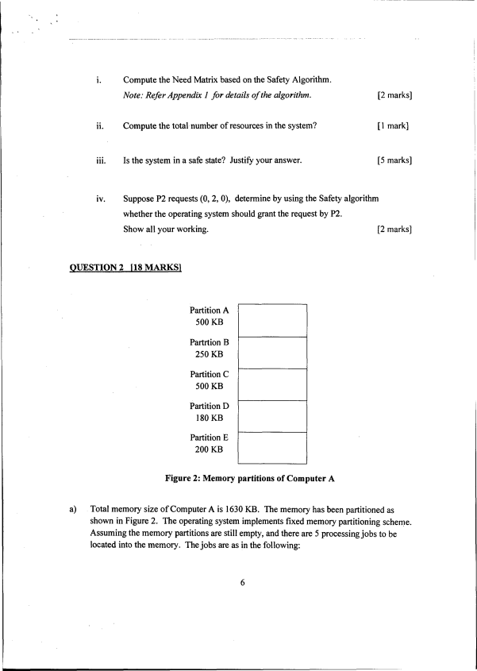
i. Compute the Need Matrix based on the Safety Algorithm.
Note: Refer Appendix 1 for details o f the algorithm. [2 marks] ii. Compute the total number of resources in the system? [ 1 mark]
iii. Is the system in a safe state? Justify your answer. [5 marks]
iv. Suppose P2 requests (0, 2, 0), determine by using the Safety algorithm whether the operating system should grant the request by P2.
Show all your working. [2 marks] QUESTION 2 H8 MARKS!
Partition A
500 KB
Partition B
250 KB
Partition C
500 KB
Partition D
180 KB
Partition E
200 KB
Figure 2: Memory partitions of Computer A
a) Total memory size of Computer A is 1630 KB. The memory has been partitioned as shown in Figure 2. The operating system implements fixed memory partitioning scheme. Assuming the memory partitions are still empty, and there are 5 processing jobs to be located into the memory. The jobs are as in the following:
6
Job 1 (300 KB), Job 2 (100KB), Job3 (220KB), Job 4 (500KB), Job 5 (180 KB).
Assuming jobs with lower ID number were created earlier than jobs with higher ID number. Answer below questions:
i. Assuming the operating system is using Best Fit memory allocation scheme. Sketch a figure to show the memory partition with all jobs
are successfully being located into the memory. [3 marks]
ii. Compute the size of internal fragmentation and the
size of external fragmentation. [2 marks]
b) Assuming there is a new computer that is called as Computer B. Main memory size of computer B is also 1630 KB. The operating system implements Relocatable Dynamic memory Partitioning scheme with Compaction. Sequence of jobs to be located into the memory is described as the following:
• In total, there are SEVEN (7) jobs to be processed by the computer. • Jobs with lower ID number were created earlier than jobs with higher ID number. • Size of Job 1-5 is exactly the same as Job 1 -5 in (1).
• Size of Job 6 is 500 KB, and size of Job 7 is 50 KB.
• By the time Job 6 is to be located into the memory, Job 2 and Job 5 are already finished.
i. Sketch a figure to show the memory partition with only
Job 1, 2, 3, 4 and 5 are in the memory. [3 marks]
ii. Sketch a figure to show the memory partition when Job 6 and Job 7 ^{are already in the memory.} [3 marks]
iii. Compute the size of internal fragmentation
and the size of external fragmentation. [2 marks] 7
c) In an operating system, assume memory is allocated as specified in Figure 3.
10K 10K 20K 3 OK 10K 5K 30K 20K 10K 15K ■
Used Unused
Figure 3: Existing memory allocation.
i. Redraw how the following set of jobs
{J1 - 30KB, J2 - 20KB, J3 - 15KB, J4 - 5KB} (in that order)
are located inside the memory using next-fit allocation. [2.5 Marks]
ii. Redraw how the following set of jobs
{J1 - 15KB, J2 - 10KB, J3 - 5KB, J4 - 30KB} (in that order)
are located inside memory using best-fit allocation. [2.5 marks]
QUESTION 3 [17 marks!
a) Explain the concept of Virtual Memory. In your explanation, you should
also highlight several advantages of Virtual Memory, and give reasons
why it is important and relevant in modern operating systems. [4 marks] b) Given the following reference string:
1321432415242
For each of the following page replacement algorithms, calculate
how many page faults will occur if 3 frames are available:
i. Least Recently Used (LRU) [3 marks] ii. Optimal Page Replacement (OPT) [3 marks]
iii. Based on your answer in a i) and a ii),
which algorithm is better? Justify your answer. [2 marks]
c) Answer the following questions about Trashing.
i. Define thrashing in the context of virtual memory. [2 marks] 8
ii. List and briefly describe TWO (2) techniques
to prevent thrashing. [3 marks]
QUESTION 4 f!5 MARKS1
a) On a simple paging system with 228 bytes of physical memory,
512 pages of logical address space, and a page size of 2” bytes, [7 marks] i. How many bits are in a logical address?
ii. How many bytes are in a page frame?
iii. How many bits in the physical address specify the page frame?
iv. How many entries are in the page table?
v. What is the size of the physical memory (specify using the correct unit size)? b) What advantage does segmentation offer over multiple variable partition? [2 marks]
c) Table 2 shows a simple segmentation system approach/method.
Table 2
^{* I 1* _ 14 ‘S , /} ^Segment ? V ,• } T tnw ,
Length
0 350 124
1 860 308
2 104 144
3 480 120
4 600 40
For each of the following logical addresses, compute the corresponding physical addresses. If the adresss generates a segment fault, indicate so. [6 marks]
i. 2,104
ii. 3,120
iii. Is physical address 475 part of the program?
iv. What is the size of this program in bytes (Note: one address, lByte)? 9
QUESTION 5 H5MARKS1
a) Figure 4 shows a diagram of disk storage containing two files, Fi 1 e 1 and Fi 1 e 2: Directory
File Address Size Next 1 512
Filel (1) 2 512 8 File2 (1) 3 512 7
File2 (3) 6 512 - File2 (2) 7 512 6 Filel (2) 8 512 20 • •
Filel (4) 11 512 - •
Filel (3) 20 512 11
l 2 3 4 5 6 7 8 9 10 11 12
13 14 15 16 17 18 19 20
Figure 4: Disk Storage
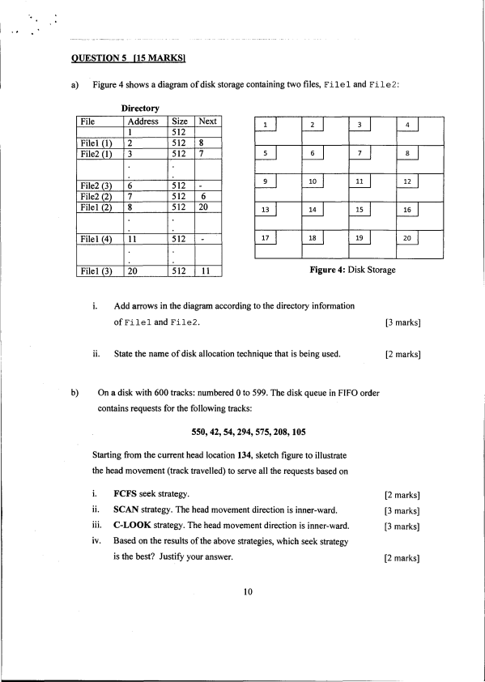
i. Add arrows in the diagram according to the directory information
of F ilel and F ile2 . [3 marks] ii. State the name of disk allocation technique that is being used. [2 marks]
b) On a disk with 600 tracks: numbered 0 to 599. The disk queue in FIFO order contains requests for the following tracks:
550, 42, 54, 294, 575,208,105
Starting from the current head location 134, sketch figure to illustrate
the head movement (track travelled) to serve all the requests based on
i. FCFS seek strategy. [2 marks] ii. SCAN strategy. The head movement direction is inner-ward. [3 marks] iii. C-LOOK strategy. The head movement direction is inner-ward. [3 marks] iv. Based on the results of the above strategies, which seek strategy
is the best? Justify your answer. [2 marks] 10
Appendix 1
Safety Algorithm
1. Let Work and Finish be vectors of length m and n, respectively. Initialize:
Work = Available
Finish[ i ] =false for i = 1 ,2 ,..., n
2. Find an index i such that both
Finishf i j — false
Need/ < Work
If no such i exists, go step 4.
3. Work = Work +Allocatiom
Finish [ i j = true
Goto step 2
4. If Finishf i / = true for all i then the system in safe state 11

